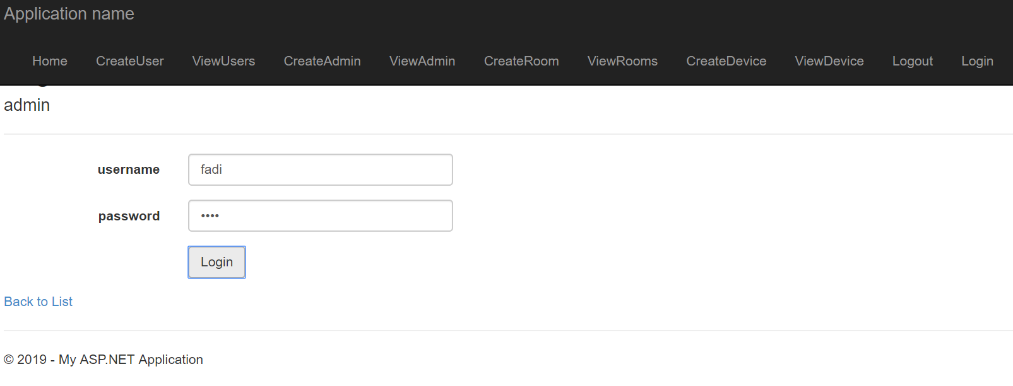

The application consists of a several tabs that allows the user to add, edit, view and remove users, admins, rooms and devices. Lastly, there is also a login and logout tab.

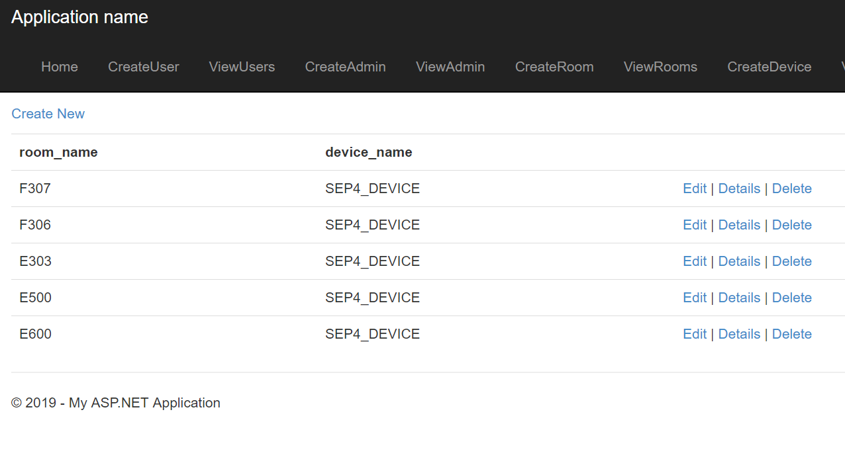

This snippet above illustrates page for viewing the rooms. The admin can from this page also directly edit and delete the rooms.

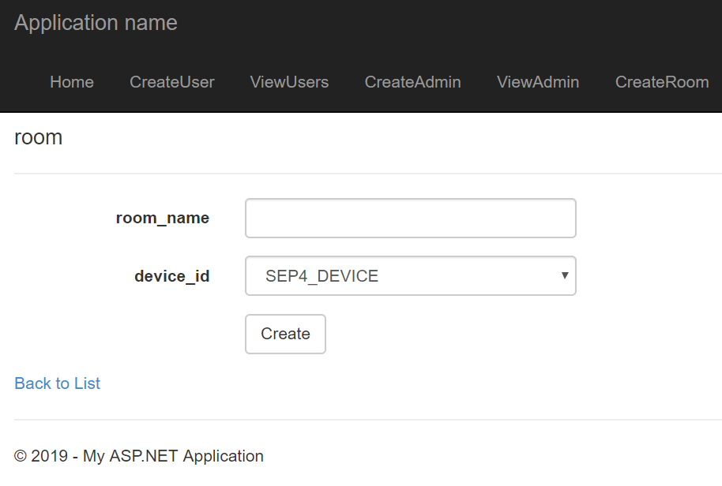

In the snippet above the page for adding room is illustrated. Since device is a foreign key to room there is drop down list to pick from existing devices.